Mobile Advisory Service dates:
Aug 2025 – Sep 2025

Sedgemoor
Area | Date | Location | Time
Cheddar | Tue 19th Aug | Sainsbury’s | 10.30am – 3.30pm
Bridgwater | Fri 1st Aug  Fri 15th Aug  Fri 5th Sep  Tue 23rd Sep | Hospital  Hospital  Hospital  Morrisons | 10.30am – 1.30pm  10.30am – 1.30pm  10.30am – 1.30pm  10.30am – 3.30pm
Burnham-on-Sea | Thurs 14th Aug | B & M | 10.30am – 3.30pm
Highbridge | Mon 8th Sep | ASDA | 10.30am – 3.30pm

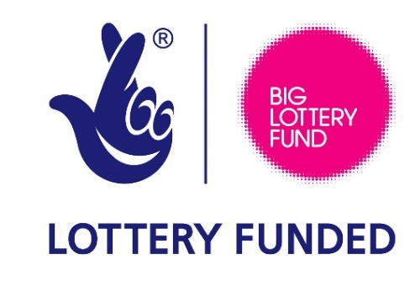

Dates may be subject to change if you are making a special journey, please call our office prior to your visit on 01823 333818.

